BarterBay User Manual

*Group 093*

*Peter Crampton - Project Manager*

*Chingiz Mardanov - Developer*

*Collin Barlage - Developer*

*Pratik Shekhar - Developer*

## 

## 

## 

## 

## 

## 

## 

## Table Of Contents

Table Of Contents

Introduction

The Mobile Application

Signing up for a BaterBay Account

Signing into a BaterBay Account

Signing into BaterBay using your Google+ Account

Signing into BaterBay using your Facebook Account

Barter Postings

Creating a New Barter Posting

Editing an Existing Barter Posting

Deleting an Existing Barter Posting

The BarterBoard

Bartering with Other Users

Conclusion

## 

## 

## 

## 

## 

## 

## 

## 

## 

## 

## Introduction

Thanks for choosing BarterBay! We appreciate you taking a chance on our application and we hope that it can serve your needs while also being easy to use and user friendly. We designed BarterBay to help users barter for items with other users of the BarterBay system. We did this by providing our users with a centralized application which manages so called “Barter postings” and also allows user to chat within the application with any user that they wish to Barter with. In this user manual we will explore all of the features that BarterBay has to offer and also will demonstrate through screenshots of the application running how to use the BarterBay application. Let’s get started!

## The Mobile Application

BarterBay is at its core a mobile application which is an application that runs on both Apple’s iPhone and also on the Android platform. The application runs as a native application and features a standard side menu design which looks like the following:

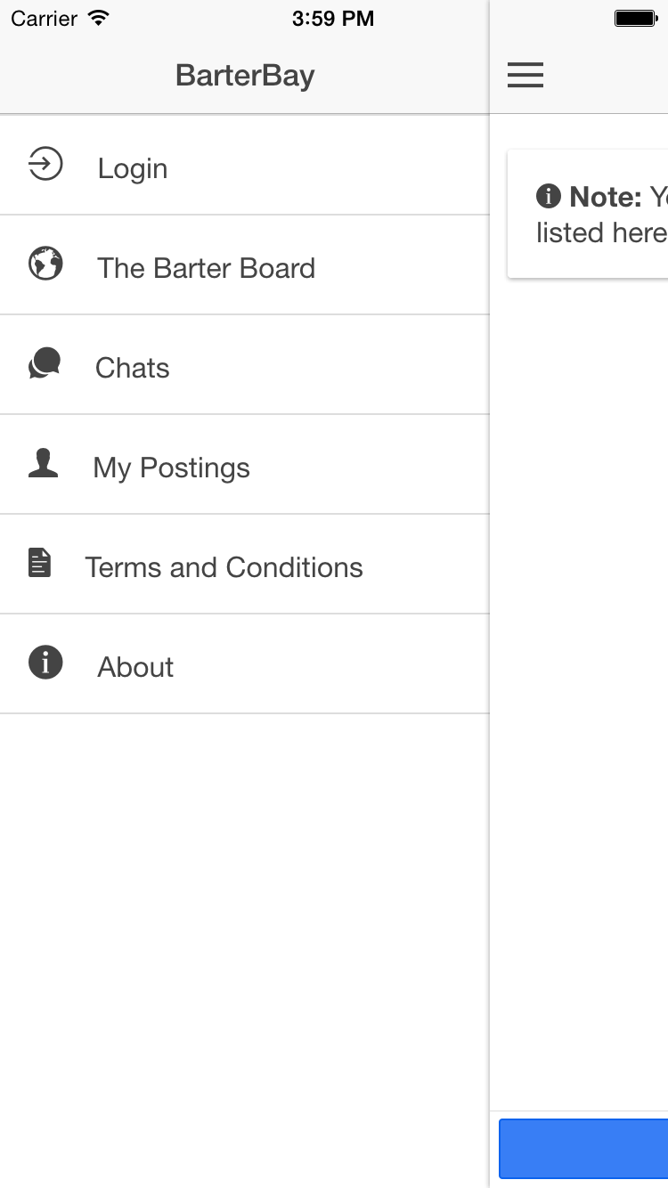

The image above shows what the side menu of the mobile application looks like. This side menu will be the primary way for you to navigate between different screens within the application.

**To open the side menu perform the following actions:**

1. Locate the side menu icon in the top left hand corner of the screen. An image with the side menu icon circled in red is shown below:

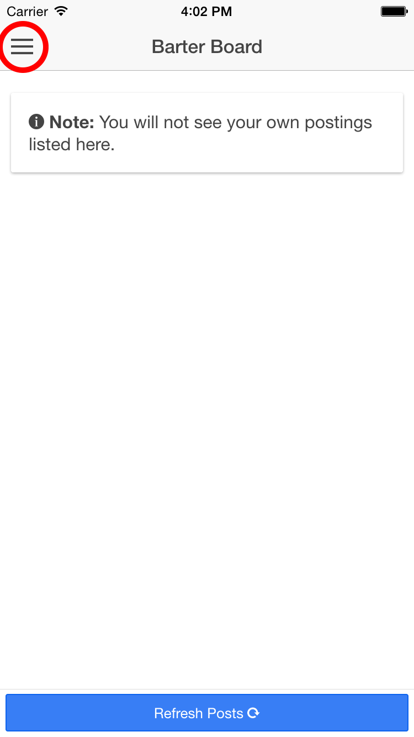

1. Click on this icon and the side menu will open.

Once the side menu has been opened, you are then free to click on any of the items within the menu. However, you will not be able to view any content until you have signed up for an account.

### Signing up for a BaterBay Account

Signing up for a BarterBay account is very simple; simply open the side menu as described above and click on the “Login” side menu element. Once you have clicked on this element, you will be shown a login dialog page as shown below:

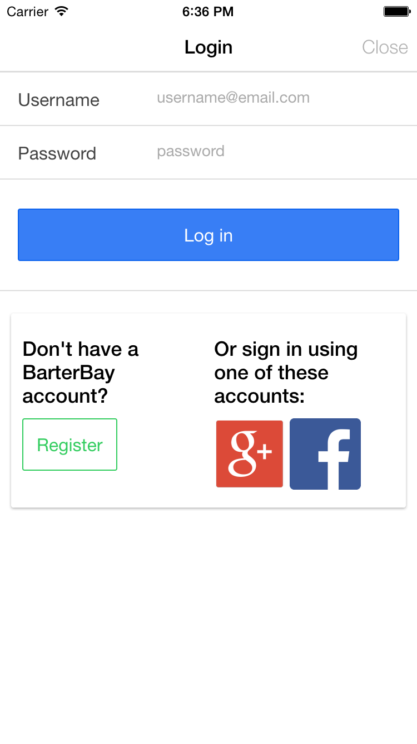

You should then click on the “Register” button seen above. After clicking this button you will be taken to a screen which looks like the following:

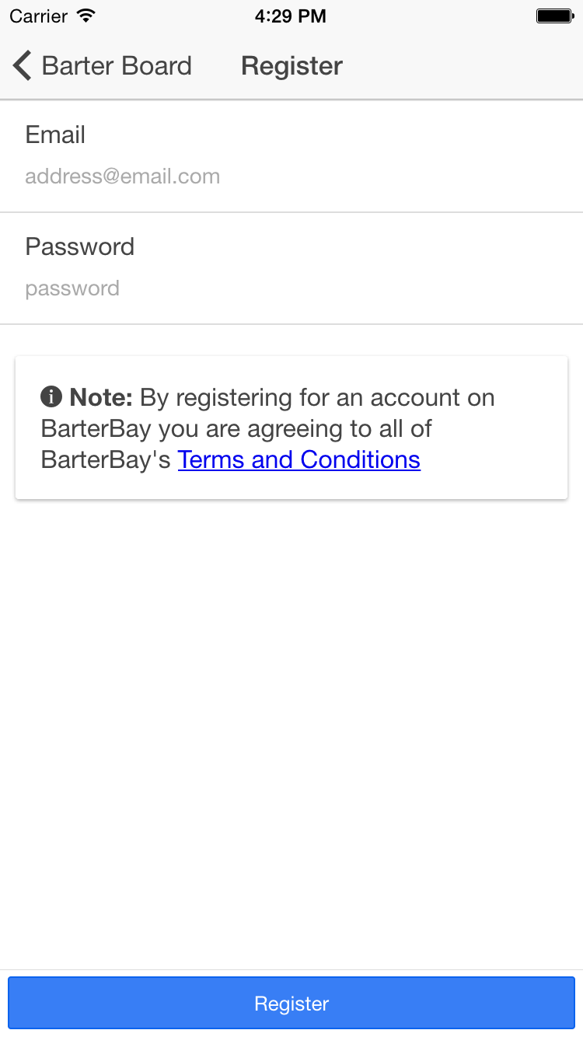

You should then fill out the form seen above entering in your information for both a valid email address and your choice of password. Once you have filled out both of these fields, simply click the Register button. This button will attempt to create an account for you using the information you supplied.

**NOTE:** If you have selected a username which already exists, the system will respond with an error telling you so, this is nothing to be concerned with, simply enter in a different email as the one you have chosen is already in use.

Once you have registered successfully you should be shown a confirmation dialog that tells you that you have been registered.

You now have a BarterBay account which you can use to log in and begin making use of the BarterBay system.

### Signing into a BaterBay Account

To sign into an existing BarterBay account, make sure you know both the email and password for the account you would like to sign in with and then navigate to the login side menu option to be taken to the login dialog. Simply enter your information and click the “Log in” button. Once you have clicked on the button you should be told whether or not you could have been logged in or not.

You should now have been signed into your BarterBay account.

### Signing into BaterBay using your Google+ Account

If you would prefer not to sign up using the BarterBay system and would rather take advantage of the option to sign in using your Google+ account, simply following these directions:

1. Click the login side menu option to open the login dialog
2. Click on the Google+ icon under the “Or sign in using one of these accounts” section of the dialog
3. You should then be taken to a prompt that looks like this:

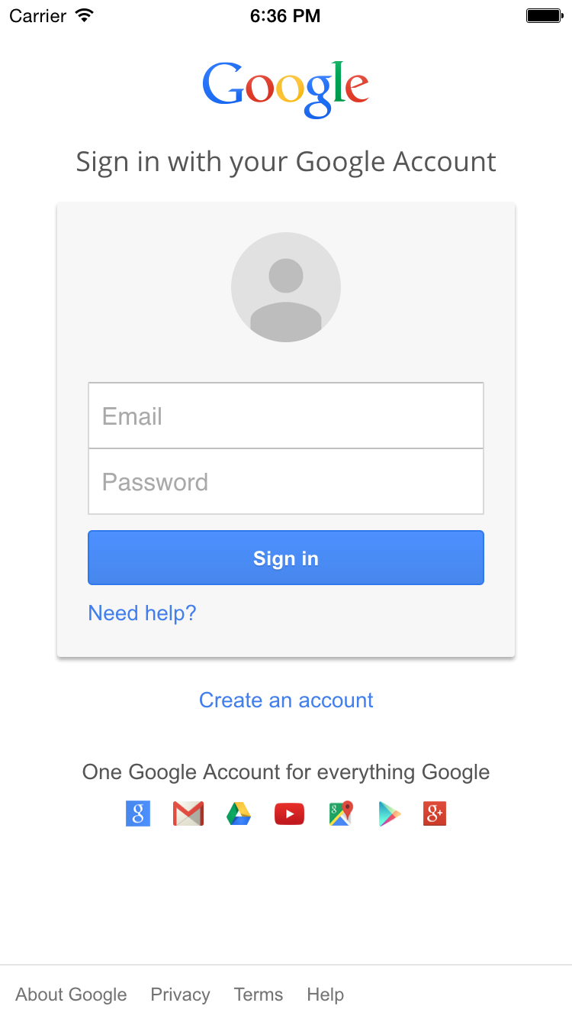

At this stage you should enter your Google+ login credentials and click the “Sign in” button shown in the image above. You will be asked to confirm that BarterBay will have permission to view basic information about your profile, you should read over this and once you have read over it thoroughly, click Agree.

Once you do this, you should receive a message from the BarterBay application that your account has been successfully authorized and linked to the BarterBay system.

You should then have been authenticated using your Google+ account.

### Signing into BaterBay using your Facebook Account

In order to sign into BarterBay using your Facebook Account, take the following steps:

1. Refer to the section on “Signing into BarterBay using your Google+ Account” for details on how to open the login dialog.
2. Once the login dialog is open, click on the Facebook icon under the “Or sign in using one of these accounts” section of the dialog.
3. You should then see a screen which looks like the following:

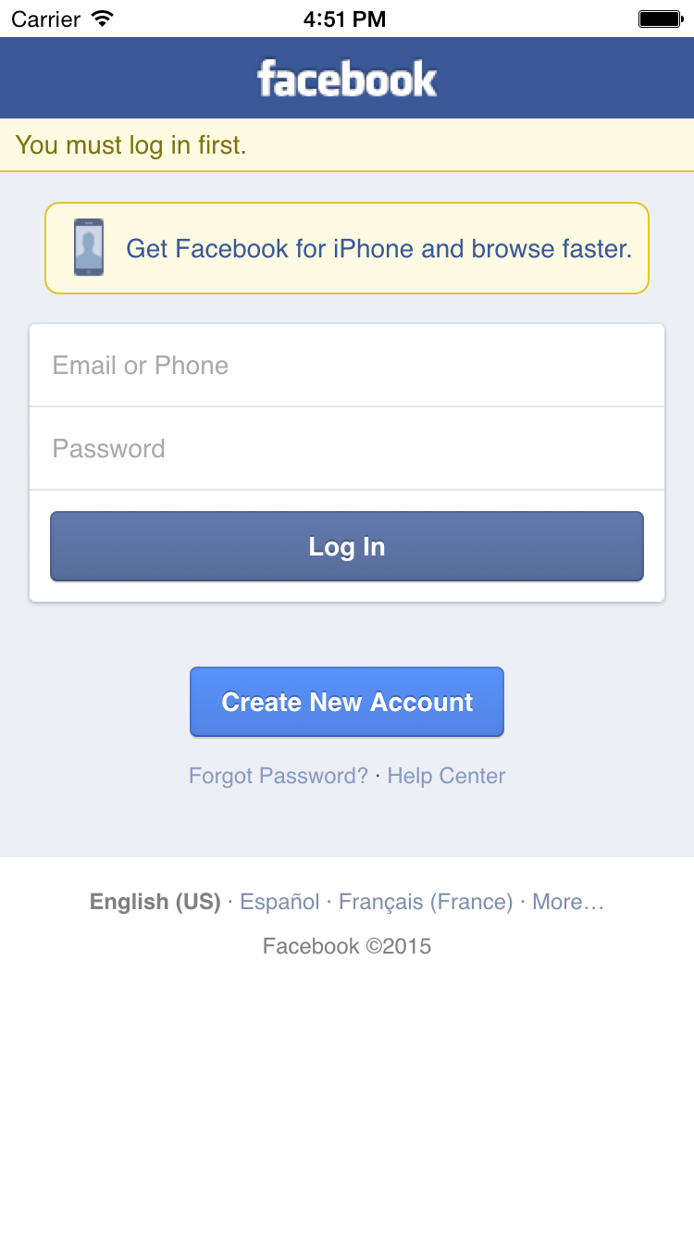

At this stage, you should enter in your credentials for your Facebook account and click the “Log In” button as seen above. You will then be asked to confirm giving BarterBay access to view basic information about your Facebook profile. Once you have read over this agreement, simply confirm and you should be taken back to the BarterBay mobile application which will report the status of whether or not you were able to log in.

## Barter Postings

Barter postings are your way of interacting with the BarterBay system. They provide the mechanism to being the Bartering process with other users. Barter postings are simply postings which you create and that provide context onto what it is that you are looking for. A barter posting will have two parts:

1. A Title - which is used to briefly tag line or summarize your posting
2. A Description - which is an in-depth description that tells other users the specifics about your posting request.

You should strive to make sure that your Barter postings are short and concise yet detailed enough to give other users an idea of what exactly you are looking for and even what you would be willing to Barter for if applicable.

### Creating a New Barter Posting

In order to create a new Barter posting, first make sure that you have been logged into an account using one of method described above.

Once you have logged in, begin by opening the side menu and clicking on the “My Postings” side menu element. You should be taken to a screen which looks like the following:

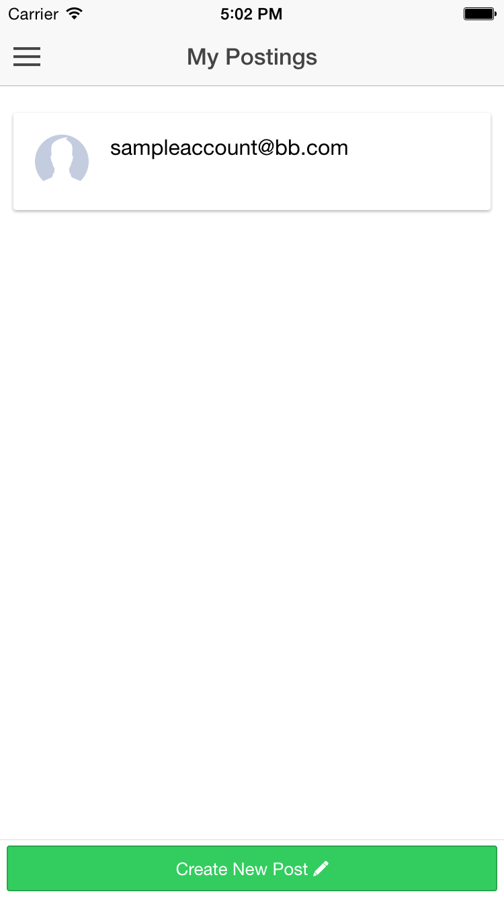

Your account email should appear in the section that in the image above says “sampleaccount@bb.com”. Once you have reached this screen, you should click on the “Create New Post” button on the bottom of the screen above. Once you have clicked this button, you should be taken to the create posting menu (seen below). From this menu you will able to fill out both the title section and description section of your new posting (both of these sections were described previously). After entering in the information for your new posting you should be then able to create this posting by clicking on the “Create Post” button (seen below).

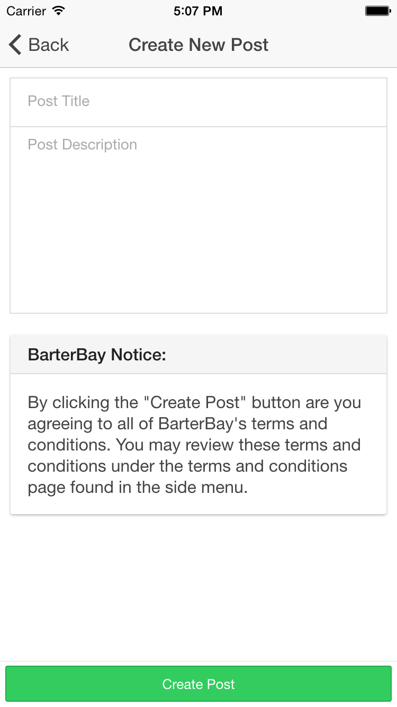

After clicking the “Create Post” button you should be taken back to your posting screen to see that a new posting has been created and is now listed under your postings as seen below:

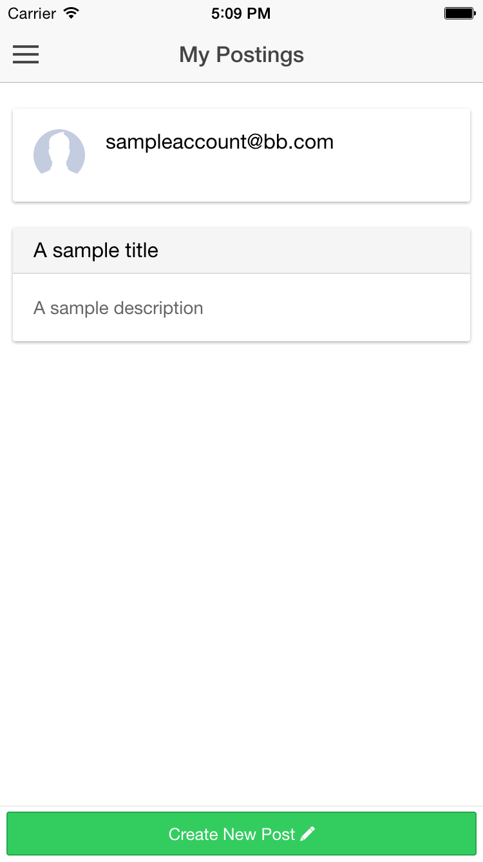

You have now successfully created a posting on the BarterBay system and your posting is now viewable to all other BarterBay users.

### Editing an Existing Barter Posting

In order to edit an existing posting, first open up your “My Postings” side menu option and then locate the posting that you like to edit.

Once you have located the posting you would like to edit click on the posting to open the edit posting menu as seen below:

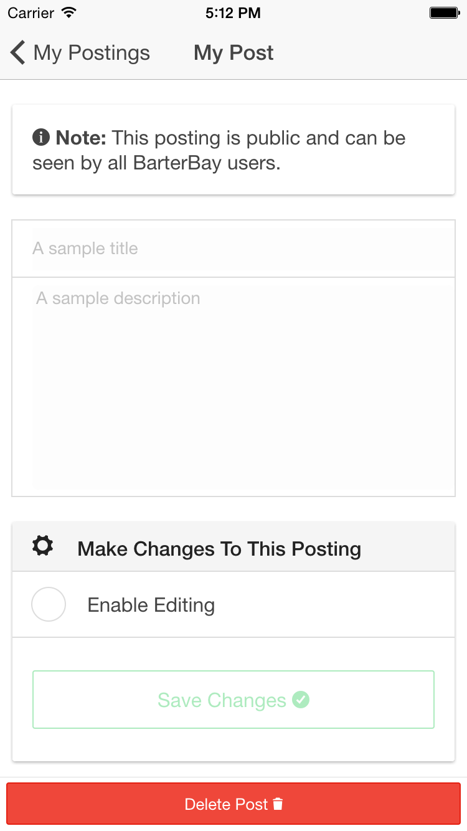

In order to change the title and description of the posting, make sure that you check the “Enable Editing” checkbox found under the “Make Changes To This Posting” section of the screen. Once you click on this checkbox to make it checked, you will enable editing of the posting title and description. You will also enable to “Save Changes” button.

You may now make revisions to your posting, changing the title and description as you see fit. Once you have finished your revisions, simply click the “Save Changes” button to save the changes that you have made. You will now notice that your changes have been made to your posting.

You have now made a change to an existing posting.

### Deleting an Existing Barter Posting

In order to delete an existing posting, simply follow these steps:

1. Open the “My Postings” side menu element
2. Click on the posting you want to delete, you will be taken to the edit posting menu
3. Click on the “Delete Post” button at the bottom of the page (seen above).

You have now successfully deleted a posting. This posting will not longer be viewable to any BarterBay users. Refreshing the “My Postings” screen will show that this posting no longer exists.

## The BarterBoard

The BarterBoard is the name given to the collection of user submitted Barter postings which altogether constitute a large library of postings from different users. The following is an example of what the BarterBoard may look like:

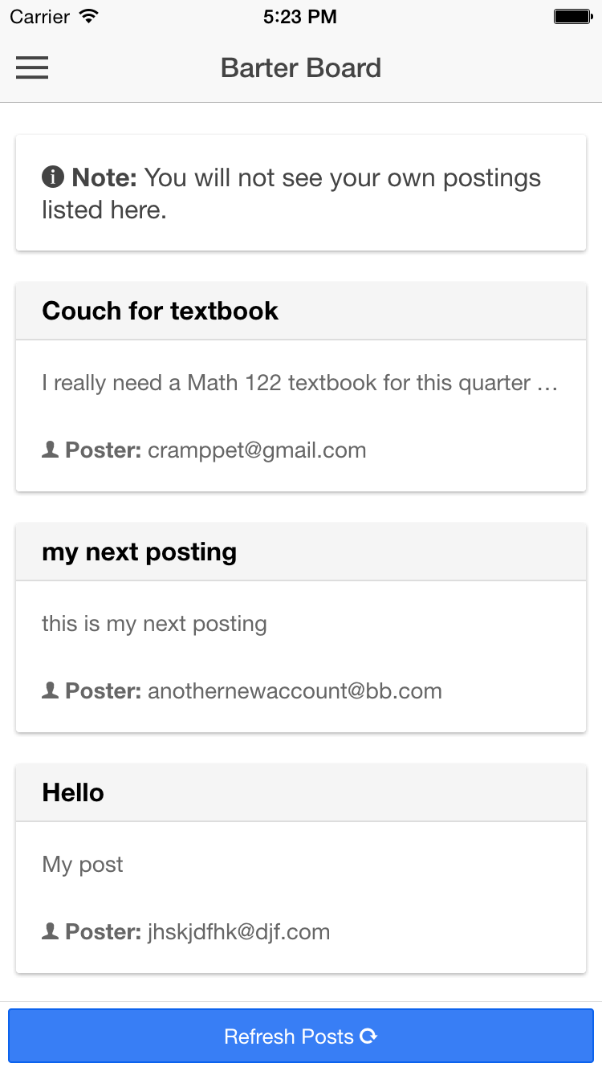

As you can see the BarterBoard is populated with postings from different users and you are to see the titles, descriptions and posting users for each of the postings on the BarterBoard. This is how your own postings will appear to other users. As per the note listed in the screen, you will not see your own postings listed on the BatrerBoard.

### Bartering with Other Users

Once you have found a posting that you like to either gain more information about or would like to make an offer to the user who originally made the posting, you should contact the user.

In order to contact the user, begin by locating their posting on the BarterBoard. Once you have located their posting, click on the posting and you will be taken to a screen which looks similar to the following:

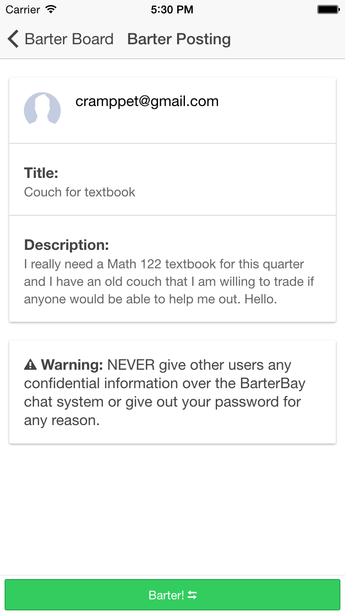

From this screen you should click on the “Barter!” button at the bottom of the screen. In so doing, you will open a conversation with the user where you can ask questions or otherwise communicate with the user and have them respond by sending messages back to you. If you were to click on the Barter! button it would look something like this:

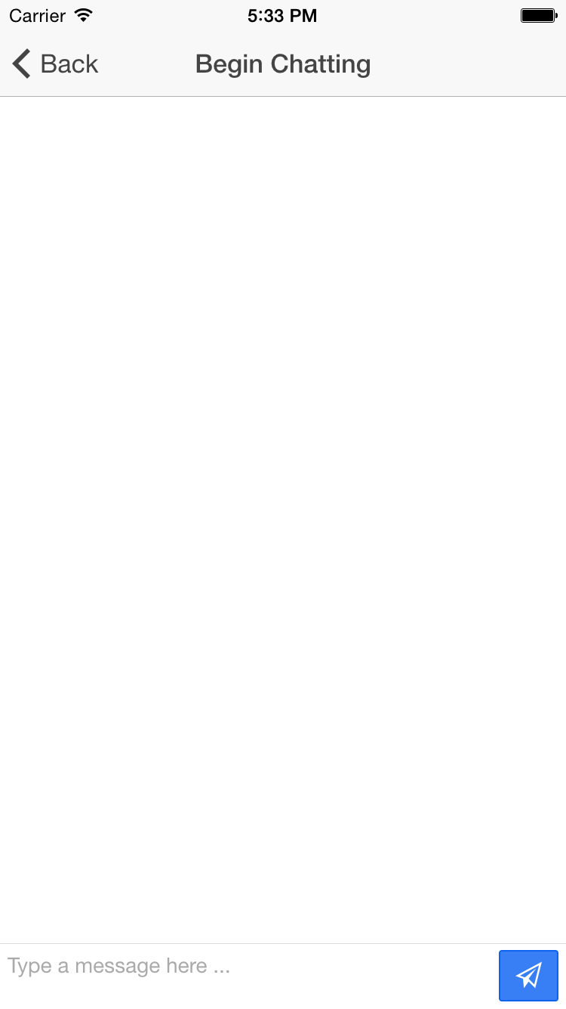

From here you may type messages and click the blue button in the bottom right hand corner to send the message to the user. The user may or may not respond and it is from here that you could work out the negotiations for the Bartering process.

## Conclusion

This guide should be enough to give you an understanding of how to use the BarterBay platform to sign up for an account, log in, create new postings, edit your posts and communicate with other users on the BarterBay system in order to Barter for different items.

Thanks for choosing BarterBay and happy Batering!